CS 499 Module One Assignment Template

Complete this template by replacing the bracketed text with the relevant information.

- Self-Introduction: Address all of the following questions to introduce yourself.

  - How long have you been in the Computer Science program?
I have been at SNHU for about 3 years.

  - What have you learned while in the program? List three of the most important concepts or skills you have learned.
I would say the 3 most important concepts are security and secure coding, Data Structure and Algorithms such as Big O notation and determining the most efficient Structures and algorithms, and Full Stack Development.

  - Discuss the specific skills you aim to demonstrate through your enhancements to reach each of the course outcomes.
During these enhancements I aim to demonstrate my ability to plan software development, plan the creation of a well-designed database, show that I understand DSA concepts such as Big O, can create secure and well designed easy to read and understand code, and can design a UI that is not only usable but decent to look at.

  - How do the specific skills you will demonstrate align with your career plans related to your degree?
I plan to pursue a job in software engineering. When it comes to software engineering, being able to plan out software and enhancements is very important. It is also important that there are no security vulnerabilities in code, it’s efficient, and that it is easy to read and understand so that not only can I maintain it but so can others both maintain the software and enhance it.

  - How does this contribute to the specialization you are targeting for your career?
Overall, I would be looking forward to something like a full stack development career. So being able to demonstrate that I can design and operate a database, query it for relevant information is also important and between the skills in section D and E I believe I will be able to demonstrate this.

- ePortfolio Set Up:

  - Submit a screen capture of your ePortfolio GitHub Pages home page that clearly shows your URL.
    - You already have a repository in GitHub where you uploaded projects in previous courses. Your ePortfolio will reside in GitHub but can link to work at other sites, such as Bitbucket.

  - Use the GitHub Pages link in the Resource section for directions on:
    - How to create your GitHub website and publish code to GitHub Pages
    - Issues, such as adding links to other sites

  - Paste a screenshot of your GitHub Pages home page with your URL clearly showing in the space below.
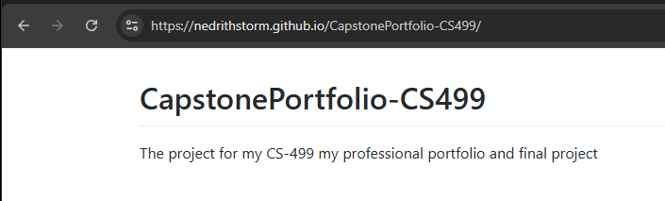

- Enhancement Plan:

  - Category One: Software Engineering and Design
    - Select an artifact that is aligned with the software engineering and design category and explain its origin. Submit a file containing the code for the artifact you choose with your enhancement plan.

    - plan. You may choose work from the courses listed under Category One.

For this category, I plan on using my artifact from Data Structures and Algorithms. During DSA we made an artifact that was to read a file, take in the courses in the fil, validate that they meet certain requirements such as every course pre-requisite existing, and use the data structure we decided was best to hold that data. It should then be searchable and modifiable. I want to take this artifact and modify it to support a GUI interface using Python instead of C++

Note: Your artifact may be work from the following courses:

- IT 145: Foundation in Application Development
- CS 250: Software Development Lifecycle
- CS 260: Data Structures and Algorithms
- IT 315: Object Oriented Analysis and Design
- CS 320: Software Testing, Automation, and Quality Assurance
- CS 330: Computational Graphics and Visualization
- CS 340: Advanced Programming Concepts
- CS 350: Emerging Systems Architectures and Technologies
- CS 360: Mobile Architecture and Programming
- IT 365: Operating Environments
- IT 380: Cybersecurity and Information Assurance
- CS 405: Secure Coding
- CS 410: Reverse Software engineering
- IT 340: Network and Telecommunication Management
- IT 380: Cybersecurity and Information Assurance

    - Describe a practical, well-illustrated plan for enhancement in alignment with the category, including a pseudocode or flowchart that illustrates the planned enhancement.

For category 1 I intend on switching from C++ to Python. I will also be using Tkinter to go from a console application to a more user friendly GUI for searching the class list and viewing pre-requisites.

I want this enhancement to upon running the .exe file, to locate courses.csv, load it in and test that the data is viable using the same criteria we used in DSA. All courses that have a pre-requisite must have that pre-requisite course exist before the course that requires it and the file must be properly formatted.

Upon loading the courses.csv file a GUI will open up either showing an error for an invalid file or the listing of all courses. It will include a text box to search for a specific course, a button to start the search, and a button to show all courses. When you click on a course, that course will show in the bottom with any pre-requisite course ids. A simple mockup of the gui is below.

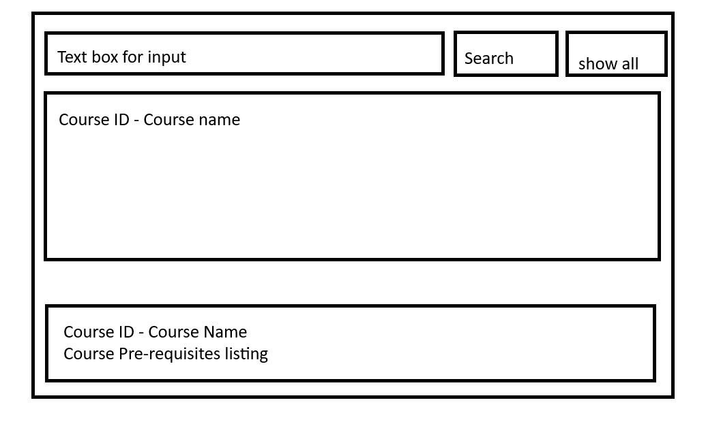

For this category of enhancement, consider improving a piece of software, transferring a project into a different language, reverse engineering a piece of software for a different operating system, or expanding a project’s complexity. These are just recommendations. Consider being creative and proposing an alternative enhancement to your instructor.

Think about what additions to include to complete the enhancement criteria in this category. Since one example option is to port to a new language, that is the kind of scale that is expected. This does not mean you need to port to a new language but instead have an equivalent scale of enhancement. Underlying expectations of any enhancement include fixing errors, debugging, and cleaning up comments, but these are not enhancements themselves.

    - Explain how the planned enhancement will demonstrate specific skills and align with course outcomes.

      - Identify and describe the specific skills you will demonstrate that align with the course outcome.

I want to show competency in multiple different languages, the C++ I originally coded the artifact in and Python.

As I’m coding I will be using proper coding techniques such as comments to ensure that my code is easier to understand.

I also Want to show that I can design a good user interface by taking the application from a console based app to a more interactive GUI that will be more user friendly.’

      - Select one or more of the course outcomes below that your enhancement will align with.

Employ strategies for building collaborative environments that enable diverse audiences to support organizational decision making in the field of computer science

Design, develop, and deliver professional-quality oral, written, and visual communications that are coherent, technically sound, and appropriately adapted to specific audiences and contexts

Demonstrate an ability to use well-founded and innovative techniques, skills, and tools in computing practices for the purpose of implementing computer solutions that deliver value and accomplish industry-specific goals

Course Outcomes:

- Employ strategies for building collaborative environments that enable diverse audiences to support organizational decision-making in the field of computer science.
- Design, develop, and deliver professional-quality oral, written, and visual communications that are coherent, technically sound, and appropriately adapted to specific audiences and contexts.
- Design and evaluate computing solutions that solve a given problem using algorithmic principles and computer science practices and standards appropriate to its solution while managing the trade-offs involved in design choices.
- Demonstrate an ability to use well-founded and innovative techniques, skills, and tools in computing practices for the purpose of implementing computer solutions that deliver value and accomplish industry-specific goals.
- Develop a security mindset that anticipates adversarial exploits in software architecture and designs to expose potential vulnerabilities, mitigate design flaws, and ensure privacy and enhanced security of data and resources.

  - Category Two: Algorithms and Data Structures

- Select an artifact that is aligned with the algorithms and data structures category and explain its origin. Submit a file containing the code for the artifact you choose with your enhancement plan. You may choose work from the courses listed under Category One.

For category 2 I will also be using the DSA artifact that I described in Category 1. As a precursor to category 3 I will be adding in the ability to use hash tables and examining the runtime differences between hash tables and vectors as I prepare to switch to a database instead of a .csv file.

- Describe a practical, well-illustrated plan for enhancement in alignment with the category, including a pseudocode or flowchart that illustrates the planned enhancement.

For this category I will be switching from Vectors to hash tables and examining the difference in runtime complexity. I will be looking at how long a complex search takes run both by vector and has tables and also looking at it on the more technical side with Big O notation. This will set me up well for my category 3 enhancement as well.

Overall the psudeo-code for this will be similar to the already existing pseudo code of the vector format. Just designed for hashes instead.

While not particularly aligned with this category I also want to focus on using my remaining time in this category to develop proper automated tests.

For this category of enhancement, consider improving the efficiency of a project or expanding the complexity of the use of data structures and algorithms for your artifact. These are just recommendations. Consider being creative and proposing an alternative enhancement to your instructor. Note: You only need to choose one type of enhancement per category.

Think about what additions to include to complete the enhancement criteria in this category. Since one example option is to port to a new language, that is the kind of scale that is expected. Perhaps you might increase the efficiency and time complexity of an algorithm in an application and detail the logic of the increased time complexity. Remember, you do not need to port to a new language but instead have an equivalent scale of enhancement. Underlying expectations of any enhancement include fixing errors, debugging, and cleaning up comments, but these are not enhancements themselves.

- Explain how the planned enhancement will demonstrate specific skills and align with course outcomes.

  - Identify and describe the specific skills you will demonstrate to align with the course outcome.

I want to demonstrate that I can properly show the advantages of choosing a good algorithm and data structure. I want to demonstrate that I understand Big O notation and the importance of designing efficient algorithms and using the correct data structure

  - Select one or more of the course outcomes listed under Category One that your enhancement will align with.

Design, develop, and deliver professional-quality oral, written, and visual communications that are coherent, technically sound, and appropriately adapted to specific audiences and contexts

Demonstrate an ability to use well-founded and innovative techniques, skills, and tools in computing practices for the purpose of implementing computer solutions that deliver value and accomplish industry-specific goals

  - Category Three: Databases

    - Select an artifact that is aligned with the databases category and explain its origin. Submit a file containing the code for the artifact you choose with your enhancement plan. You may choose work from the courses listed under Category One.

For this category, I plan on using my artifact from Data Structures and Algorithms. During DSA we made an artifact that was to read a file, take in the courses in the file, validate that they meet certain requirements such as every course pre-requisite existing, and use the data structure we decided was best to hold that data. It should then be searchable and modifiable. For this category I want to ditch the file and switch to a SQLite database instead.

    - Describe a practical, well-illustrated plan for enhancement in alignment with the category, including a pseudocode or flowchart that illustrates the planned enhancement.

For category 3 I will be further enhancing the artifact to go from a .csv file to a SQLite database. SQLite is close to MYSQL and works well for local applications. The goal if this artifact was continued to be developed would be for a full stack switching from SQLite to MYSQL as a relational database.

I will also be enhancing the artifact to add additional information to courses so that courses can have classes which can have instructors assigned to them and students registered for them. A course might have 0 to many classes which each have an instructor in charge of it and 0 to many students assigned to it.

This portion of the code will also be vulnerable to attacks such as SQL injection. So I will be more focused on a security vulnerability mindset.

I plan on having multiple tables in a single database. The course table, a collection of all courses, including their department code, and description.

The pre-requisites table. The course id and the pre-req course id in each row.

The department table, a table of department codes and their department name.

The student table, a table of students with student id, first name, middle name, last name, courses signed up for currently.

The instructor table. Instructor id, name, highest degree.

The class table. Class Id, course id, instructor id.
Now that I have the Gui already built I’d like to expand it to add to and remove courses, departments, classes, instructors, students, and pre-requisites from the database with valid error checking.

For this category of enhancement, consider adding more advanced concepts of MySQL, incorporating data mining, creating a MongoDB interface with HTML/JavaScript, or building a full stack with a different programming language for your artifact. These are just recommendations; consider being creative and proposing an alternative enhancement to your instructor. Note: You only need to choose one type of enhancement per category.

Think about what additions to include to complete the enhancement criteria in this category. Since one example option is to port to a new language, that is the kind of scale that is expected. Perhaps you might increase the efficiency and time complexity of an algorithm in an application and detail the logic of the increased time complexity. Remember, you do not need to port to a new language but instead have an equivalent scale of enhancement. Underlying expectations of any enhancement include fixing errors, debugging, and cleaning up comments, but these are not enhancements themselves.
    - Explain how the planned enhancement will demonstrate specific skills and align with course outcomes.

      - Identify and describe the specific skills you will demonstrate that align with the course outcome.

Creating and designing a database that can be read from to get specific information from. Security vulnerability checks to ensure that SQL injections aren’t possible.

      - Select one or more of the course outcomes listed under Category One that your enhancement will align with.

These enhancements will Demonstrate an ability to use well-founded and innovative techniques, skills, tools in computing practices for the purpose of implementing computer solutions that deliver value and accomplish industry-specific goals.

It will also develop a security mindset that anticipates adversarial exploits in software architecture and designs to expose potential vulnerabilities, mitigate design flaws, and ensure privacy and enhanced security of data and resources

- ePortfolio Overall Skill Set

  - Accurately describe the skill set to be illustrated by the ePortfolio overall.
    - Skills and outcomes planned to be illustrated in the code review

When I conduct my code review I want to be able to point out flaws and points where the code could be improved. I also want to say where I found the code to be rather good. I want to show that I can deliver professional-quality oral and visual communications ontop of this written communication and the written communication for the journal. I want to point out the value of proper commenting and readable code as this is code I haven’t really looked at for over 2 years. It will also show the quality of my code reviews when working with others as part of a team and meet outcome 1.

    - Skills and outcomes planned to be illustrated in the narratives

The narratives show that I can look at my artifacts, determine what can be enhanced, and come up with a plan to enhance it. I have to justify my work using written communication. It will help with outcome 2 and 3.

    - Skills and outcomes planned to be illustrated in the professional self-assessment

In the professional self-assessment I plan on demonstrating my ability to communicate why an employer should consider. It will show off all of my accomplishments and skills both in this final project and from college and my normal life. This will help show my written communication skills and that I can work with others to support all of the outcomes.

